

Phagwara, Punjab

**GROCERY WEBSITE**

**INTERNET PROGRAMMING LANGUAGE**

**CSE 326**

**SUBMITTED BY**

**P. LOHIT SREE K19RD B37 11905245**

**DALAVAI SURYA K19RD B38 11909510**

**ANUPAM KUMAR DWIVEDI K19RD B39 11913131**

**Student Declaration**

This is to declare that this report has been written by us. No part of the report is copied from other sources. All information included from other sources have been duly acknowledged. We aver that if any part of the report is found to be copied, we are shall take full responsibility for it.

______________

Pilla Lohit Sree

K19RDB37

______________

Dalavai Surya

K19RDB38

______________

Anupam Kumar Dwivedi

K19RDB39

Lovely Professional University, Phagwara

8th April, 2020.

**TABLE OF CONTENTS**

**TITLE** **PAGE NO.**

|  |  |
| --- | --- |
| 1. Background and Objectives | 5 |
| 1. Description | **6** |
| 1. Work Division | **7** |
| 1. Implementation 2. Description of Work division | **8**  **18** |
| 1. Technology and Frameworks | **19** |
| 1. SWOT Analysis 2. References | **19**  **20** |

BONAFIDE CERTIFICATE

Certified that this project report “Online Grocery Website” is the bonafide work of “Pilla Lohit Sree”, “Dalavai Surya”, “Anupam Kumar Dwivedi”, who carried out the project work under my supervision.

____________________

Ms. Ishatpreet Kaur

**BACKGROUND AND OBJECTIVES OF THE PROJECT**

Food is one the basic necessity for any living organism. Like air, water and land, foo is also one of the most important in life. Nutritious food is important for a human to grow in a good shape. Because, regardless of the amount of food one eats, if the food is not nutritious, he/she won’t be getting enough energy to survive. So a balanced and a nutritious diet is required to ensure a proper growth of a person or a living organism.

.

We all go to supermarkets and groceries stores to buy essential food and all other stuff. All of us make sure that we eat proper food, nutritious food right? We buy various vegetable, fruits, meat, snacks, ketchups, and so forth to ensure that a nutritious as well tasty recipe would be made at home. But, we look for the best of all the groceries that are available; at times we also look at prices of them. Sometimes we might find surprisingly large crowds in the super markets or grocery stores; we might become stressed by shopping, and looking for the best things available. Sometimes while travelling from home to supermarket we might get stuck in traffic, because of the delay we might miss our most important moments in lives. Life doesn’t provide us many such moments right? so no one wants to miss such moments. That’s the reason we are here! We have decided to create a website that provides the entire required groceries just one tap away from them. We provide various varieties of vegetables, fruits, snacks, beverages, sweets, chocolates and many more at the least prices all at a single tap away from you. We provide the best quality foods and pleasing services. And our website is called “Omni basket”!

After receiving this project we all had started our background work of how to establish our website. We went through some of the best online grocery stores likes Amazon, Flip kart, Big basket etc., which made us inspire of what needs to be done, and what needs to be there in our website so that we could end up doing an elegant project. Then, we have chosen of what needs to be done like number of web pages, the effects in each of the web pages, etc. And, later we allotted our works and we are proud to say that we had completed as we thought.

Our webpage provides its users. This website is made to list out the basic functionalities of a webpage in which the basic concept of us on HTML and CSS are questioned and the concept of a webpage related to online grocery store is shown creatively with grandeur.

**Objectives**

* To design a Home Page of an Online grocery store.
* Home Page including all the basic elements like Revolution, Advantages, Products, About Us, Login / Sign Up and some information about food.
* This Webpage enables one to go through all products we have, and know more about Omni basket.
* Provide basic queries and functionalities about the payments, delivery and service.
* To keep website simple and creative.
* To keep the website easy for a customer / client to use.
* To use HTML, CSS and JavaScript to design the webpage and make it more interactive to the user.

And, our goal was to make a website of Online grocery store , which can serve the end-user with logging in, signing up, stalk all the products and services we offer, choose the desired product along with discounts and buy it, know about us, contact us (if they have any queries), etc. And, we are very happy to say that we had achieved what we had thought of doing.

**Project Outcome**

* We got a clear image of how to use HTML and CSS and some part of JavaScript in designing a website.
* We got to know about many functions and various scripts in JavaScript.
* We got to know how to position each and every component of the website according to our need.
* Group co-operation and teamwork is really important to complete any group task and leadership skills are needed in most of the circumstances.
* We got to know that we must stop thinking of extra things after some extent, or else we would go on adding new things to our website but it would never be completed.

**DESCRIPTION OF THE PROJECT**

The website has 6 modules in total. The homepage will contain all the modules in a navigation panel. When we click on the title or on “Omni basket” we will get a page that will show a brief explanation about Omni basket.

* **Products**

This section is going to consist of the details of what all products and services we provide to the customers. This webpage will give a brief of the products we provide. It will contain a list of all the products that we provide.

* **Revolution**

This section will contain about the idea of online grocery store and some description about food in the whole world. This will contain information about the current situation of food in the whole world.

* **Advantages**

This module will consist of the various advantages for customers and clients for using our website for purchasing or selling various products. This page will be solely for the customers’ knowledge.

* **About Us**

This page will consist of details of our company, the hardships we faced to get to this level, how these ideas stroke our mind. Our company’s motto and detailed description about our functionality and some information about membership, products we provide, assurance and our policy.

* **Contact Us**

This page will consist of all the contact information about Omni basket and the addresses of various branches all over India.

* **Log In / Sign Up**

This section is for the customers or clients that consult us very frequently. They can take membership of our community so that they get more offers and better benefits from our side.

**IMPLEMENTATION OF THE PROJECT**

* **Homepage**

This is the homepage of the website “Omni basket”, its top portion consists of a header which displays the logo and the name of the website. It consists of a search bar at the top right hand corner. It consists of a navigation bar that consists of all the modules like ‘Revolution’, ‘Products’, ‘Advantages’, ‘Login / Sign Up’ and another division called ‘More’. The ‘More’ division consists of a full page navigation panel that opens when it is clicked upon.

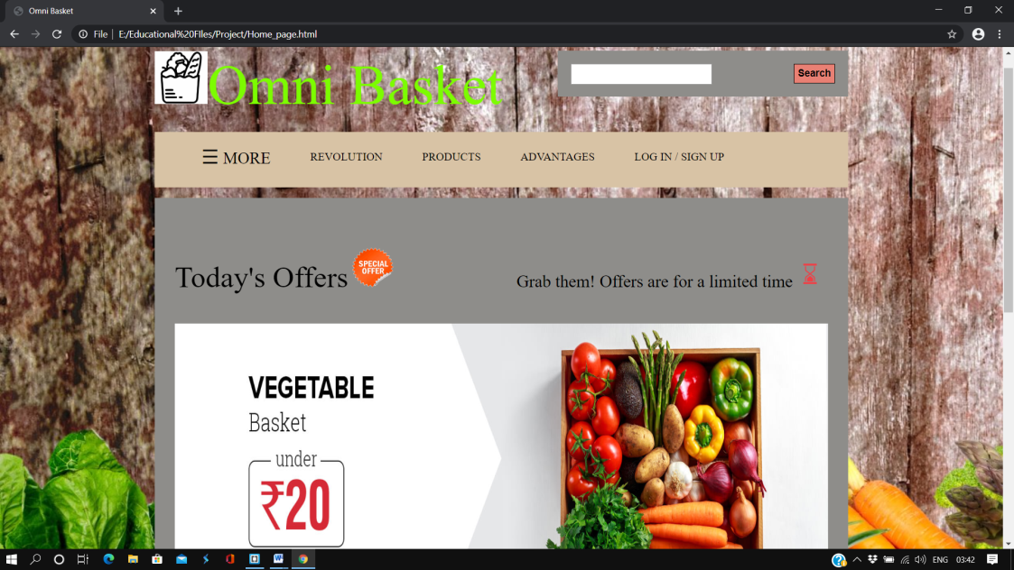

The middle portion of the webpage consists of an image slider, in which the offers available are displayed automatically. The bottom portion of the webpage consists of two divisions. The division on the left side displays the challenges we as humans are facing, regarding food and sustainable development. The right division of the bottom portion consists of details regarding the free sample. And when we click on the image, we will be redirected to the Sign Up page because one must have an account before he/she can apply for the free sample.

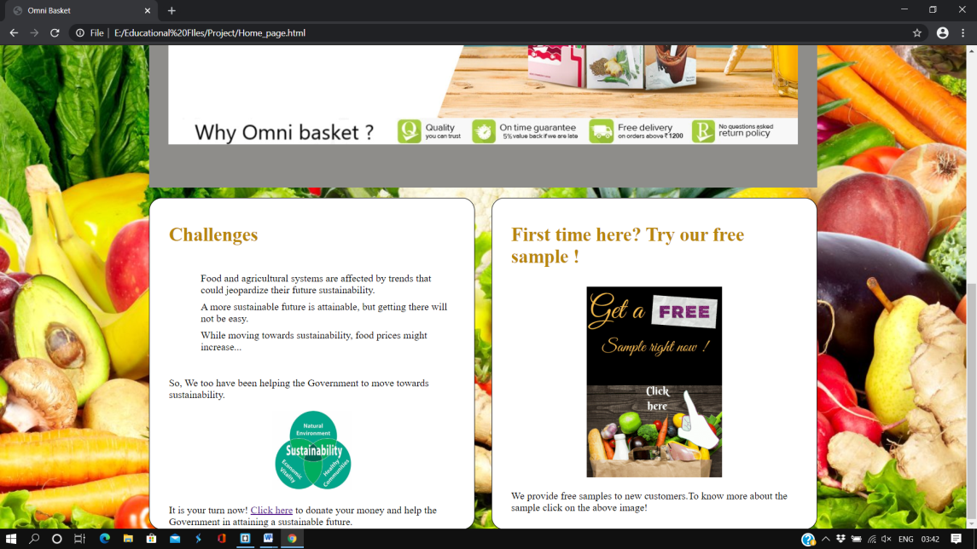

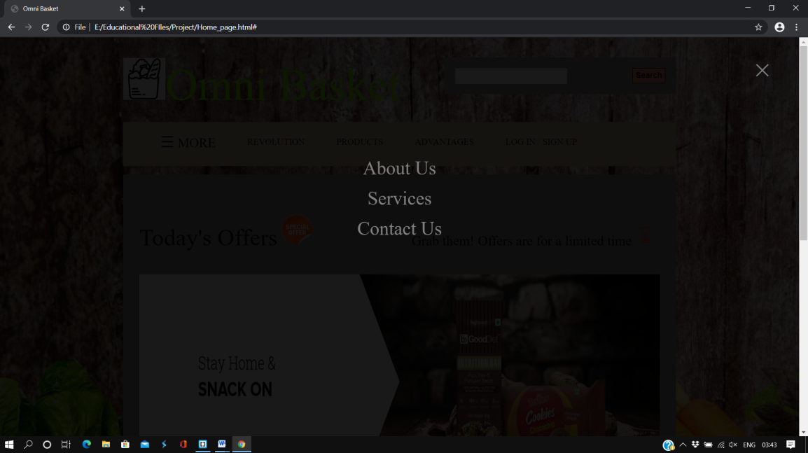The ‘More’ division consists of a full page navigation panel that opens when it is clicked upon. As shown below the navigation panel will consist of the modules ‘About Us’ and ‘Contact Us’.

When we press on About Us we will be redirected to the ‘About Us module’.

* **About Us**

This is the webpage of ‘About Us’ module; it consists of the details of the ‘Omni basket’ website. It will consist of quiet a lot of content.

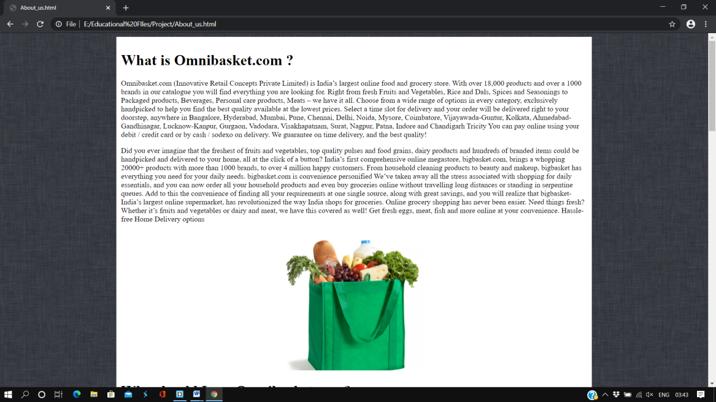

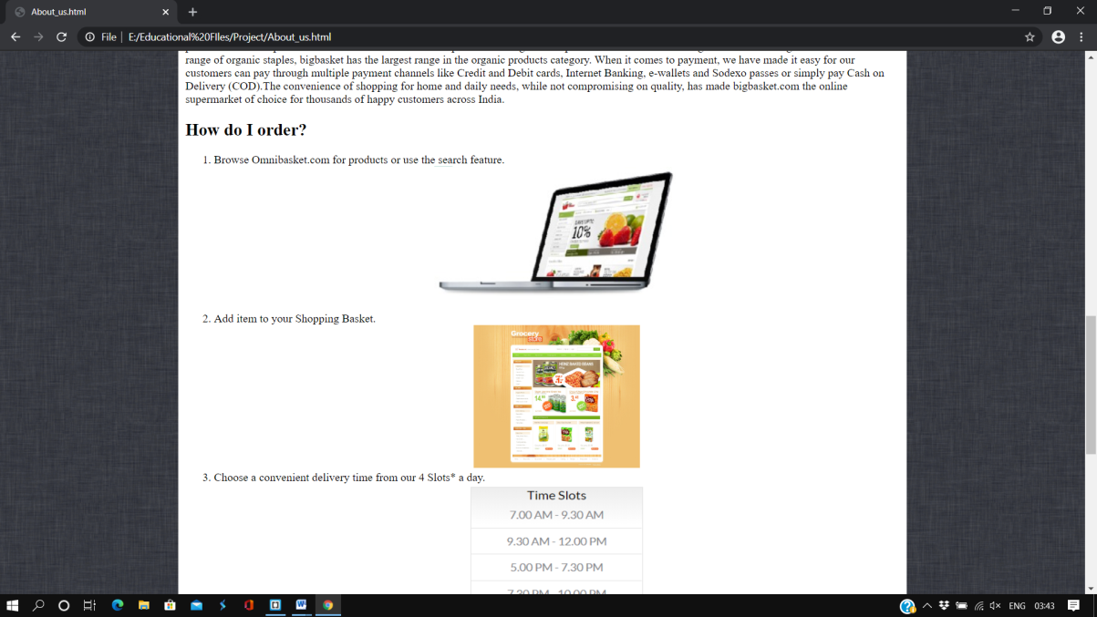As shown below the ‘About us’ webpage would also consist of steps for the customer to order. It will show the detailed steps that a customer has to follow, in order to buy a product.

As shown below, the bottommost portion of ‘About us’ webpage would consist details of our branches all over India. It also consists of a link ‘Return to Home’; when we click on it, we will be redirected to the Homepage of the website “Omni basket”.

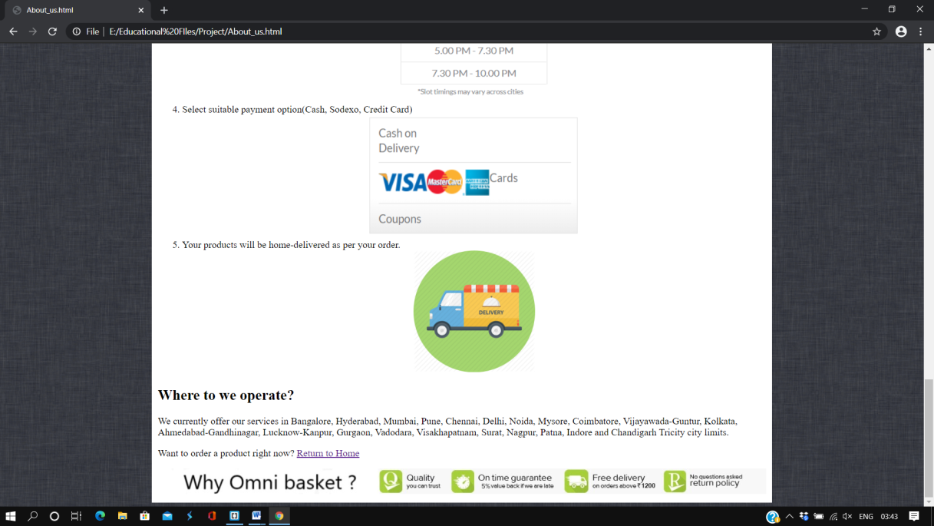

In the navigation panel, if we click on ‘Services’ then we will be redirected to a loading page. If we click on Contact Us, then we will be redirected to the “Contact Us” module.

* **Contact Us**

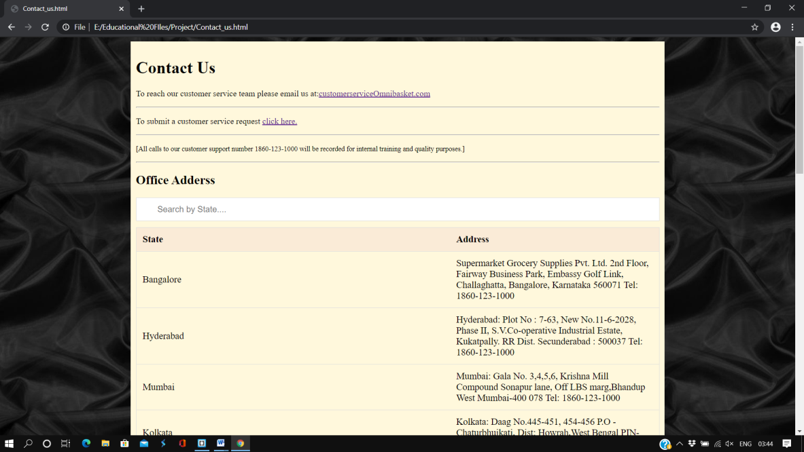This is the webpage of “Contact Us” module. It is a page that consists of contact details, customer service request link a table that contains all the addresses of all offices of “Omni basket”. We can even use the search bar in finding out the office address of the office present in a particular state/region.

The bottommost portion of this ‘Contact Us’ webpage will consist of links of Facebook and twitter when we click on them, loading page is displayed. It also consists of a link ‘Return to Home’; when we click on it, we will be redirected to the Homepage of the website.

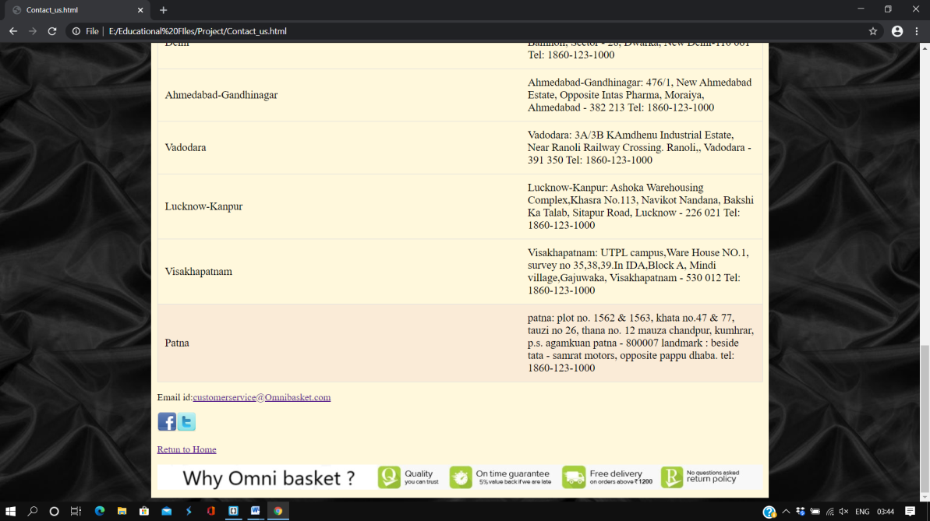

* **Revolution**

In the homepage of “Omni basket” when we click on ‘Revolution’, in the navigation bar,

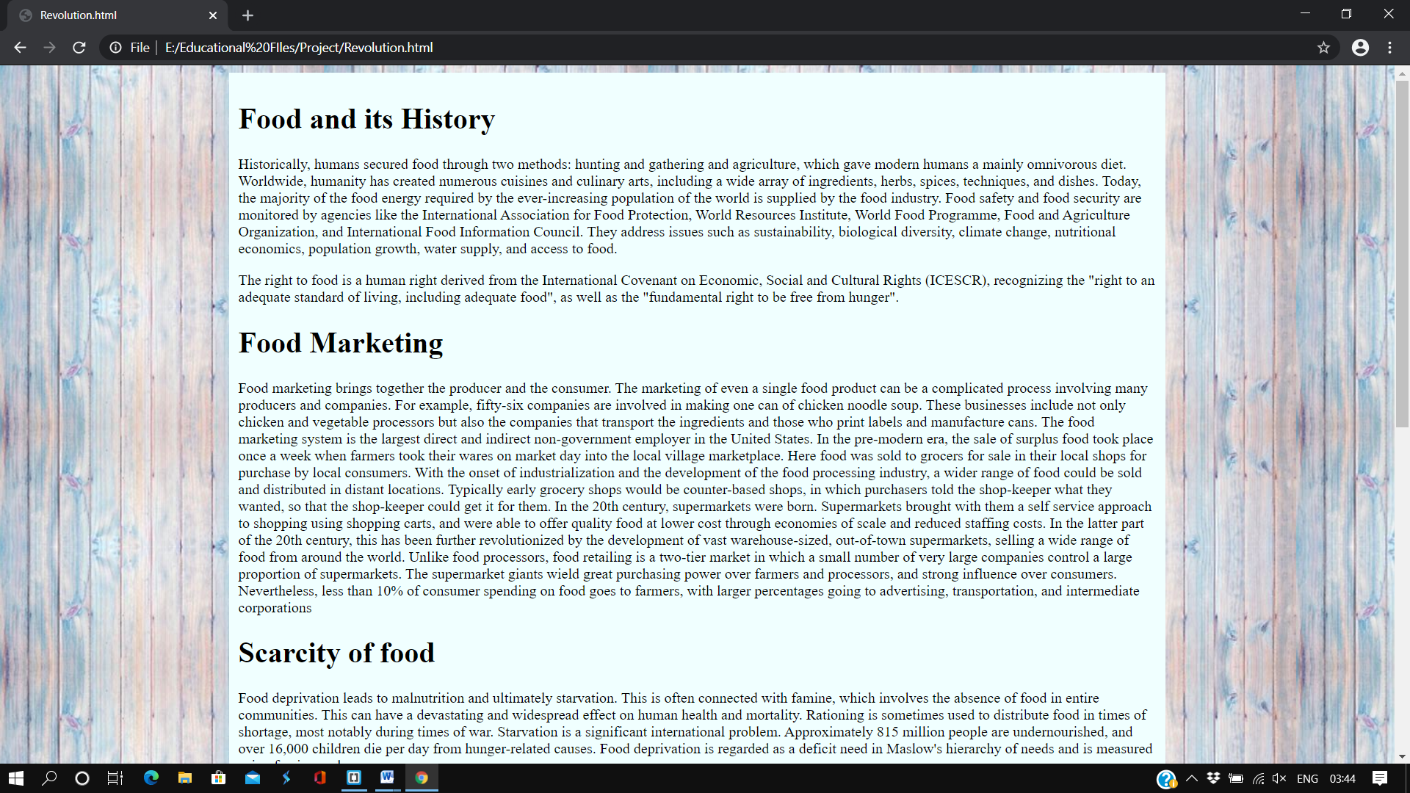We will be redirected to the “Revolution” module. This section will contain about the idea of online grocery store and some description about food in the whole world. This will contain information about the current situation of food in the whole world.

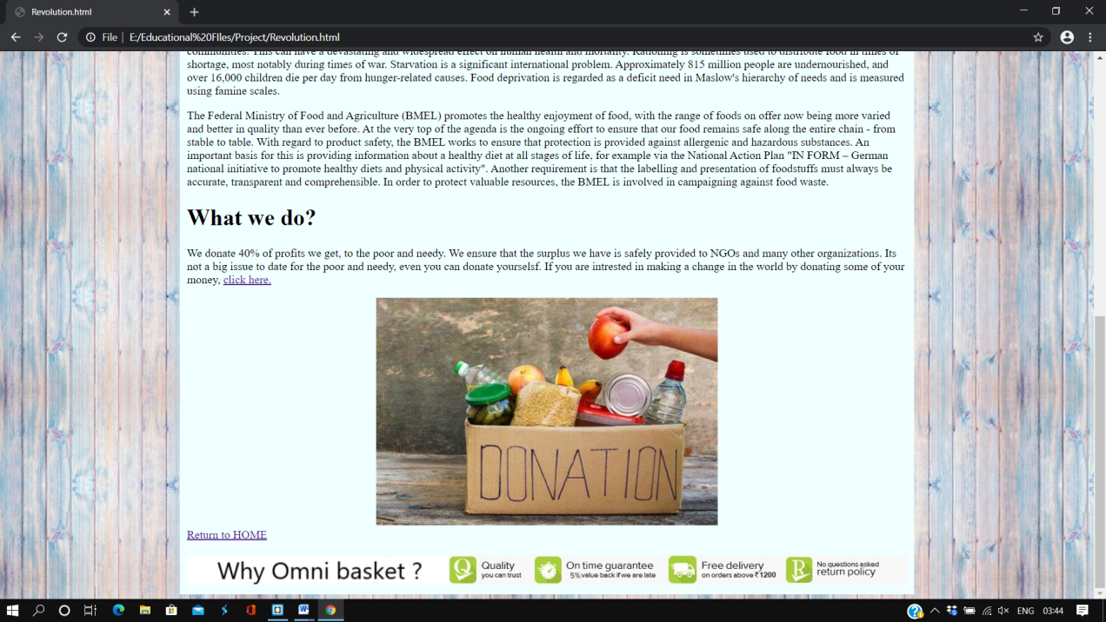The bottommost portion of this ‘Revolution’ webpage will consist of a link ‘Return to Home’; when we click on it, we will be redirected to the Homepage of the website.

* **Products**

In the homepage of “Omni basket” when we click on ‘Products’, in the navigation bar, we will be redirected to the “Products” module. The webpage of ‘products’ module will consist of all the products that are delivered by “Omni basket”. We can even search for any product.

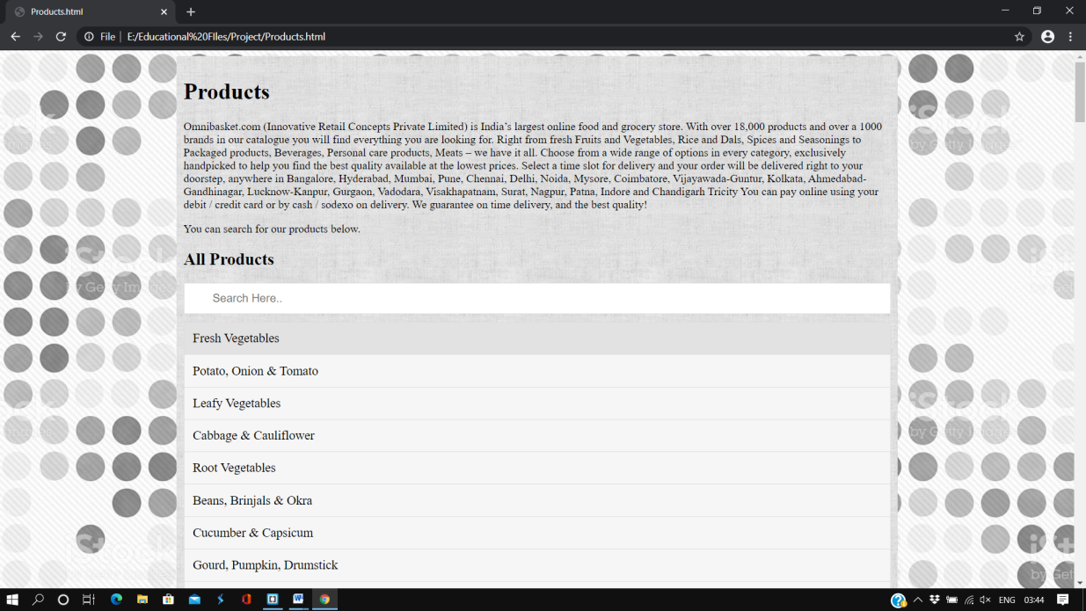

The bottommost portion of this ‘Revolution’ webpage will consist of a link ‘Return to Home’; when we click on it, we will be redirected to the Homepage of the website.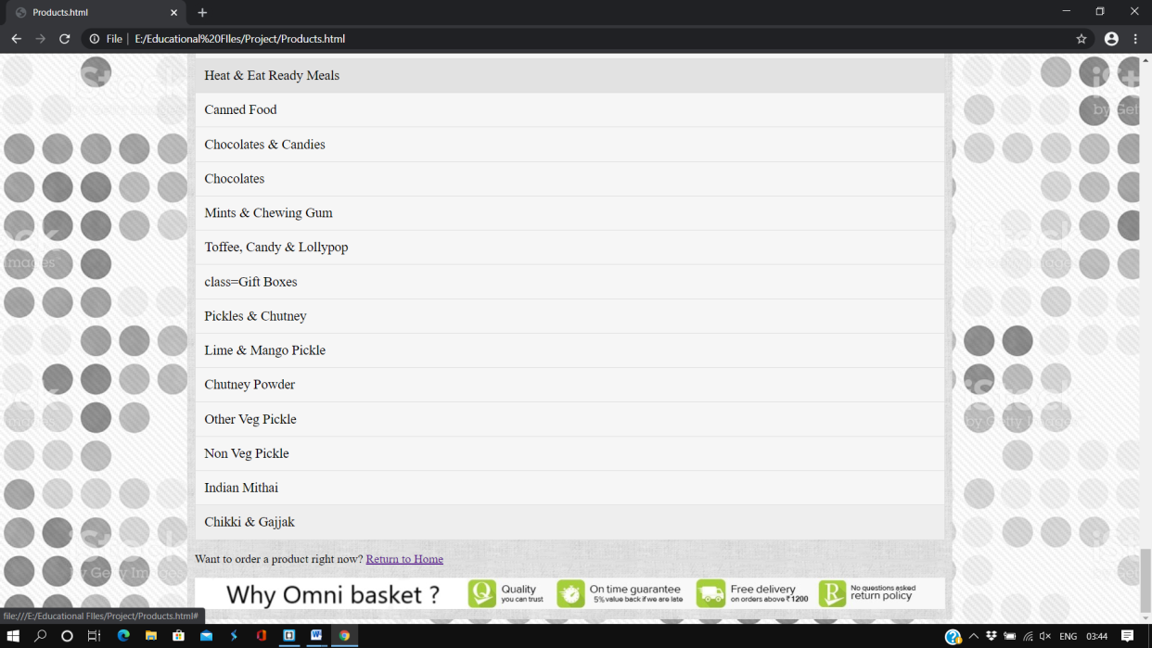

* **Advantages**

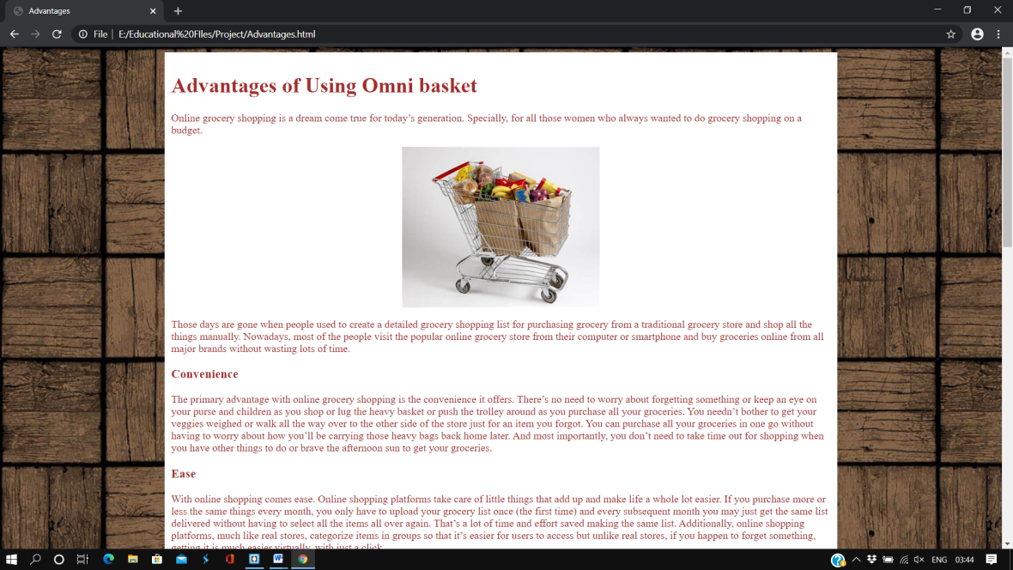In the homepage of “Omni basket” when we click on ‘Advantages’, in the navigation bar, we will be redirected to the “Advantages” module. The webpage of ‘advantages’ module will consist of information regarding benefits, customers would get using “Omni basket”.

The bottommost portion of this ‘Revolution’ webpage will consist of a link ‘Return to Home’; when we click on it, we will be redirected to the Homepage of the website.

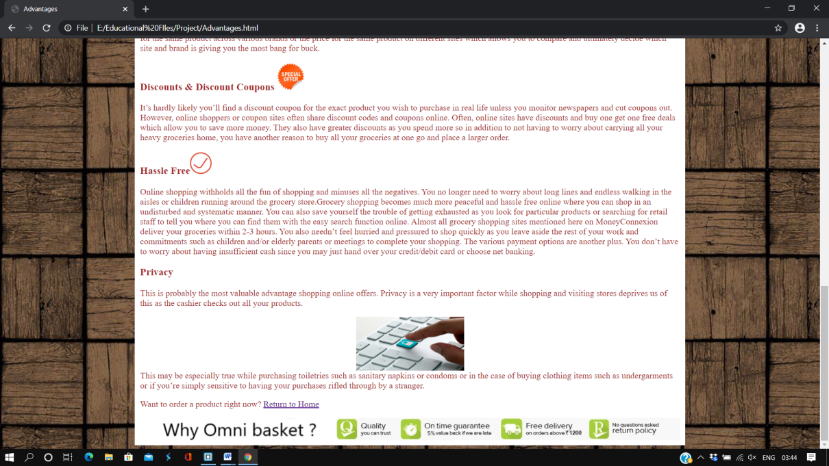

* **Login / Sign Up**

In the homepage of “Omni basket” when we click on ‘Login / Sign Up’, in the navigation bar, we will be redirected to the “Login / Sign Up” module. This module consists of a ‘login’ button, when we click on it, a login form will appear. If we press on sign up, on the left side we will be redirected to ‘Sign Up’ page.

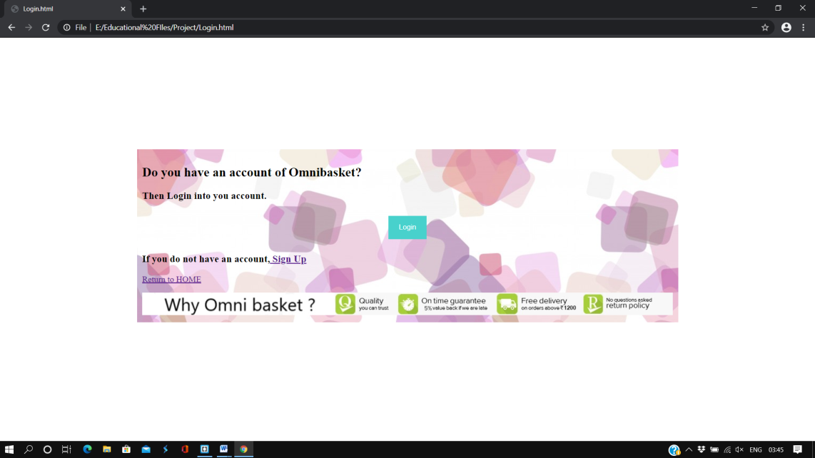

When we click on Login button in the above page, we will get a form that looks like the below image.

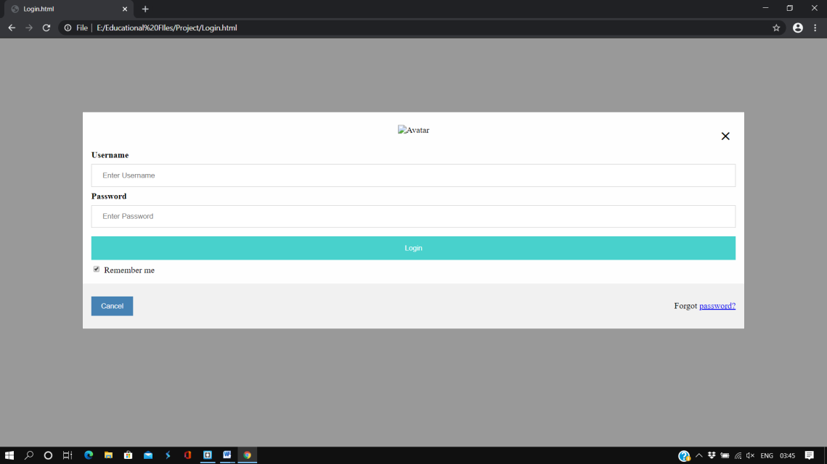

When we click on ‘sign up’ in the “Login / Sign Up” webpage, we will be redirected to another similar page, which looks like this.

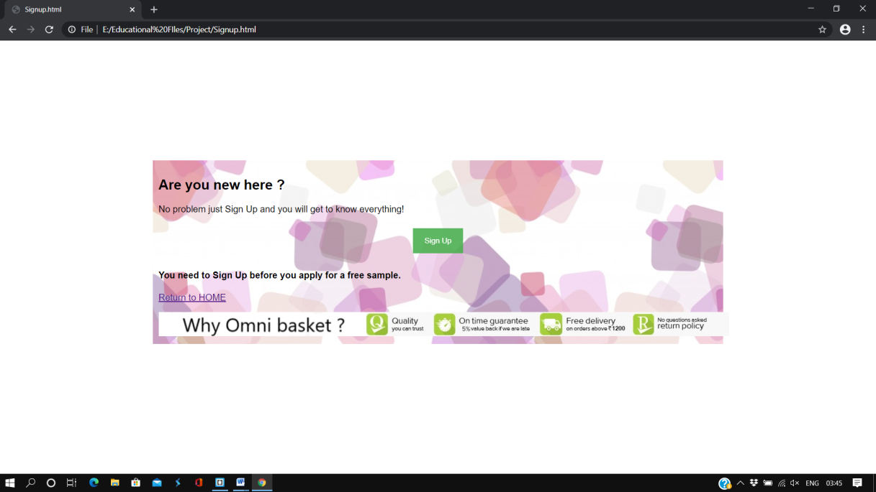

If we press on ‘Sign up’ button, we will get a form that looks as below image.

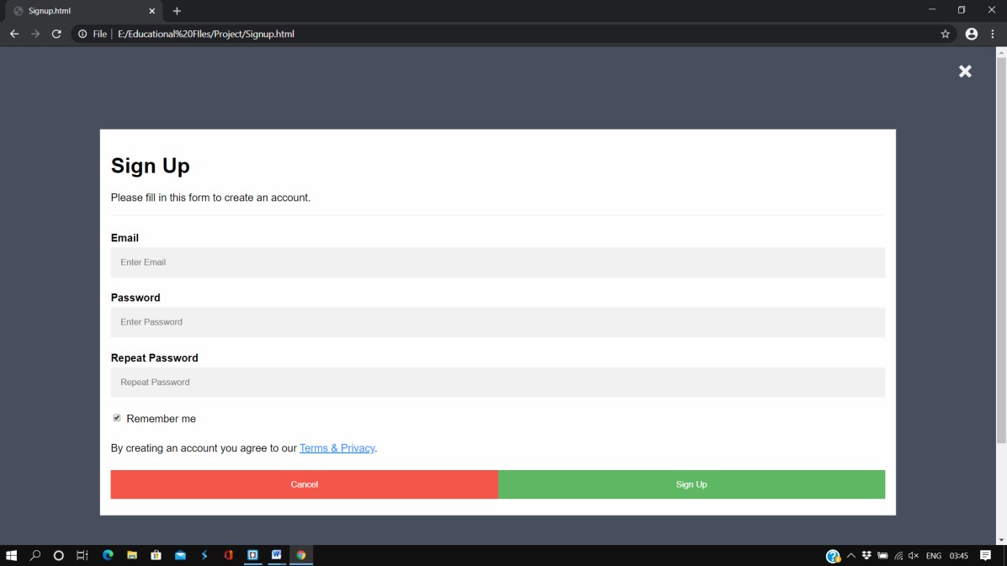

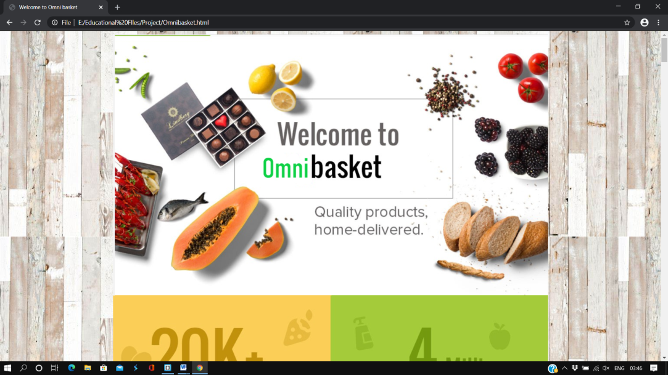Finally, if we press on the logo or on the name ‘Omni basket’, in the homepage, we will get the below webpage. It will consist of brief information regarding Omni basket.

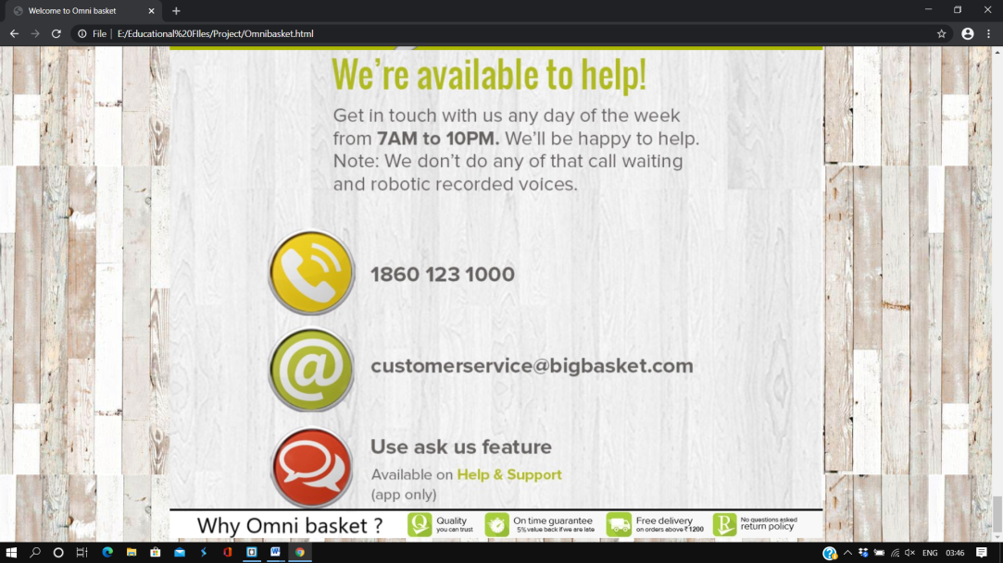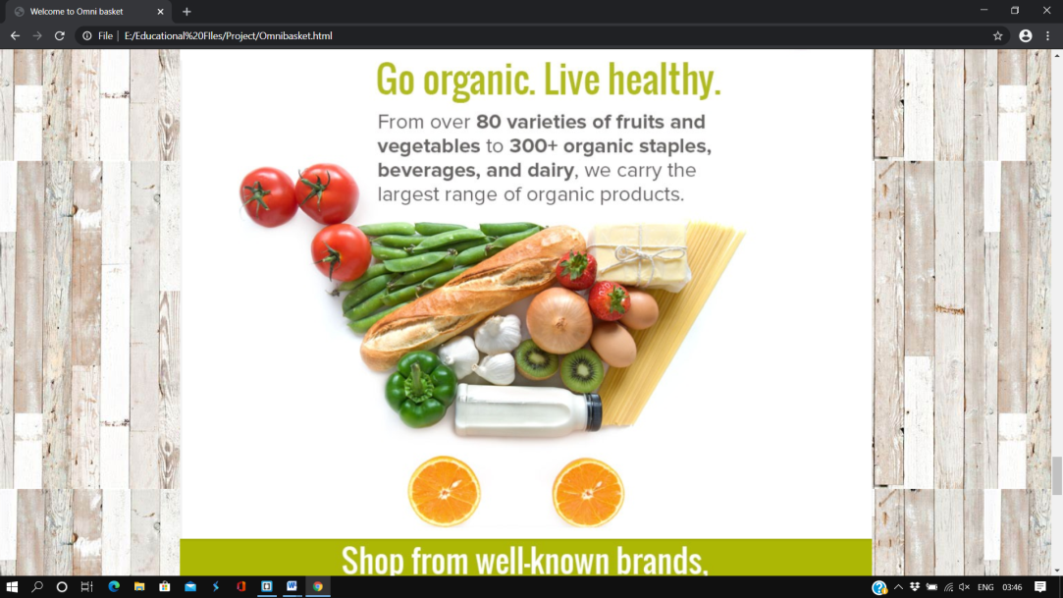

This is the loading page I used.

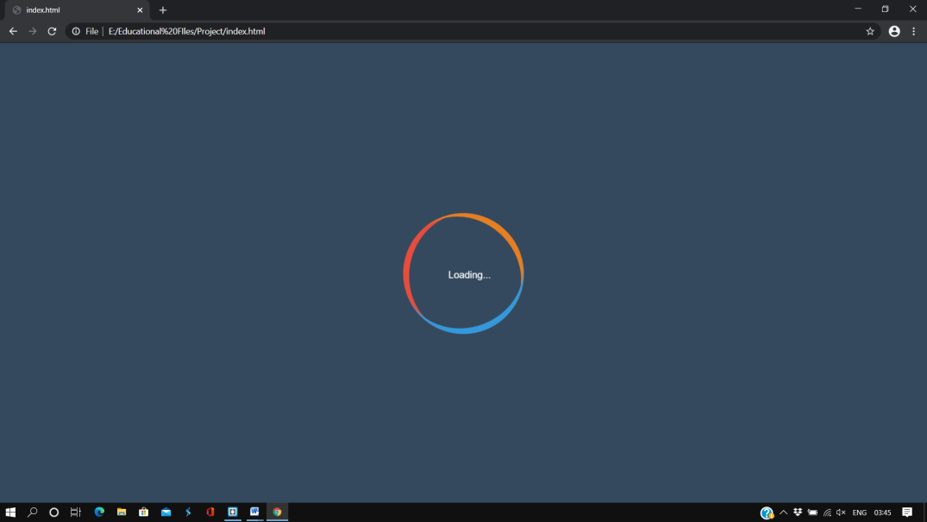

**DESCRIPTION OF WORK DIVISION**

Since there are 3 persons in our group and there are many modules to make in our web page after some discussion, we have allocated tasks within ourselves as follows:

1. P. Lohit Sree

Reg no: 11905245

Roll no: 37

* Designed the complete homepage, ‘login /Sign up’ webpage, ‘About Us’ module and ‘Advantages’ module using HTML, CSS and JavaScript.
* Making Video and Report.

1. D. Surya

Reg no: 11909510

Roll no: 38

* Designed the ‘Revolution’ module, ‘Contact Us’ module, using HTML, CSS and JavaScript.
* Taking printouts.

1. Anupam Kumar

Reg no: 11913131

Roll no: 39

* Designed the ‘Products’ module, ‘Contact Us’ module, using HTML, CSS and JavaScript.
* Gathering information regarding the website.

**TECHNOLOGIES AND FRAMEWORKS USED**

In this project, the technologies we used are:

* HTML
* CSS
* JavaScript

And, the frameworks we used are:

* Notepad++
* Sublime Text
* Brackets

**SWOT ANALYSIS**

1. **STRENGTHS:** The Strengths refers to the tangible and intangible advantages the hotel has at its disposal. The Strengths of our website includes,

* User-friendly website
* Organised
* Durability
* Quality
* Expertise at management level
* Services Offered

1. **WEAKNESS:** The weakness refers to elements that hold back the website from growth or optimal performance. The weaknesses are,

* Lacking Certain facilities
* Can be a Better Portfolio
* Lack of Connectivity to the Database and Internet

1. **OPPORTUNITIES:** The Opportunities refers to things you could do to increase customers and sales or boost your profits. The Opportunities includes,

* Increase in demand for online hotel management websites in India
* Affordable Prices for buying groceries.
* Services cover major cities, which helps to get more business.

1. **THREATS:**  The Threats refers to anything that poses a risk to my grocery website. The Threats to the website hold,

* High Competition involving poaching of delivery staff.
* Price Comparison and discounts offered.
* Have to compete with well-driven websites.

**REFERENCES:**

* Tutorialspoint
* W3school
* YouTube
* Google